**“Ingenious Making in the Early Modern World” Syllabus**

**ARTH 295 (OC)**

**Spring 2022**

Professor Christina Neilson (she, her, hers)

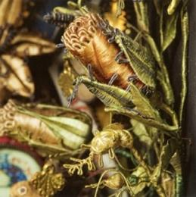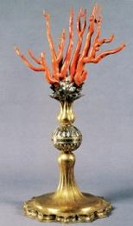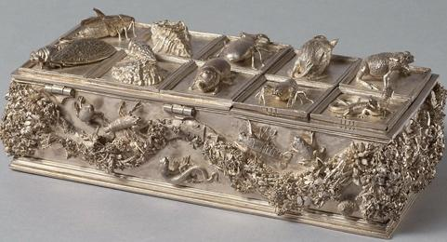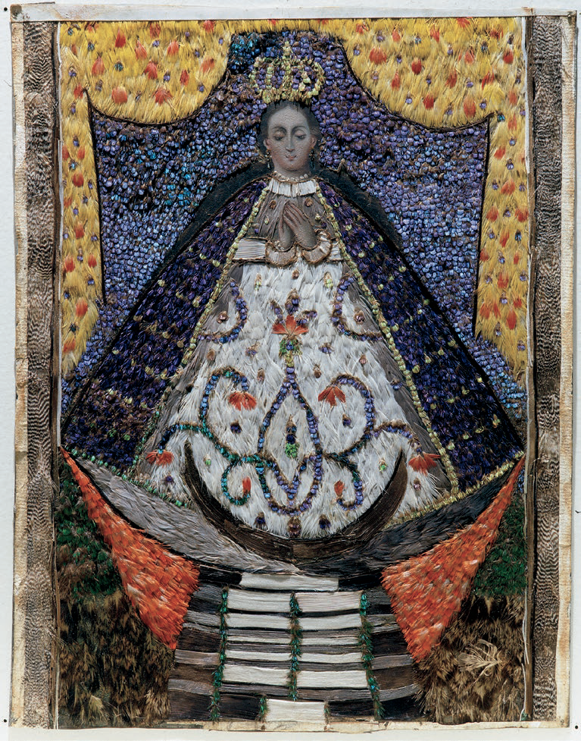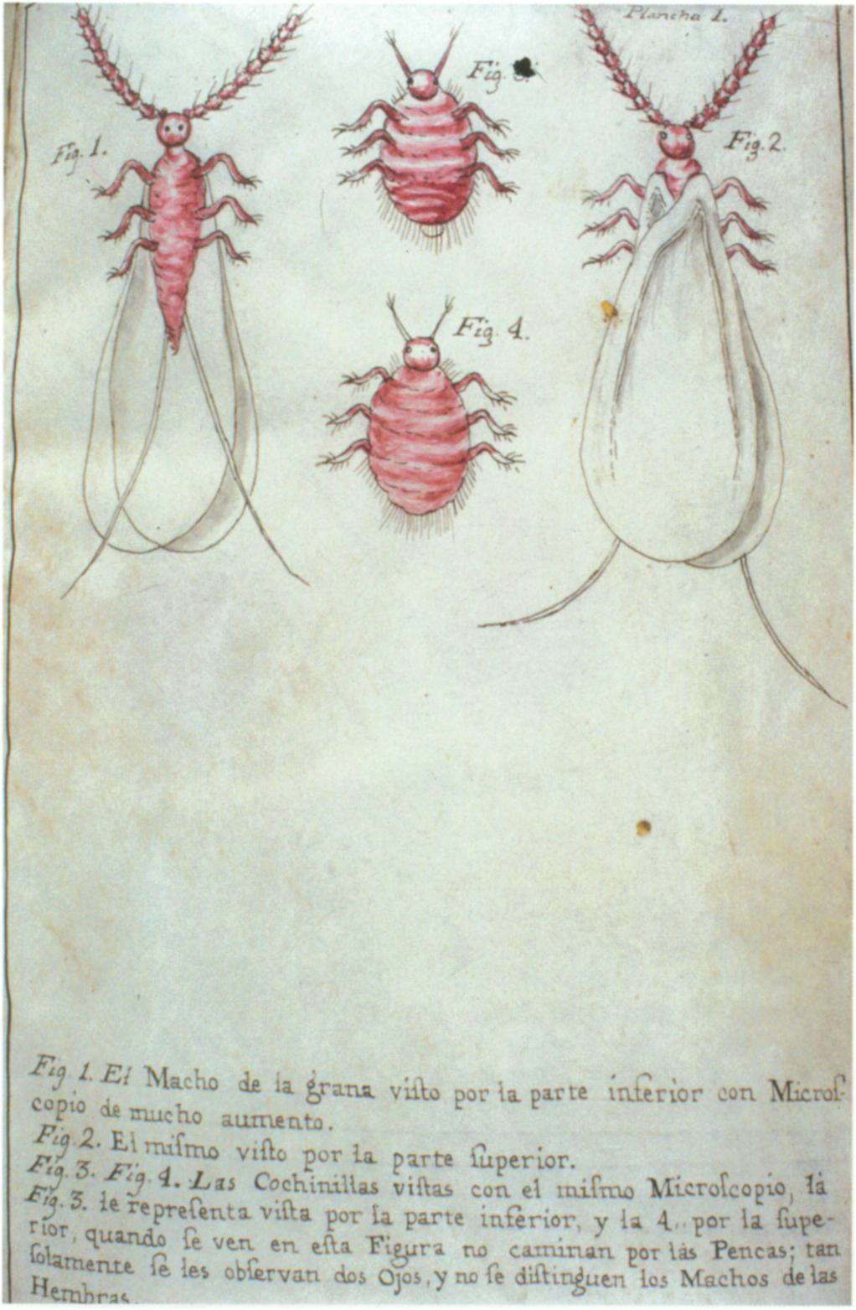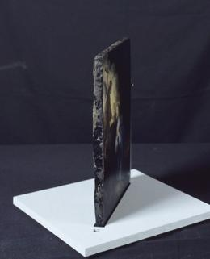

My thanks to conservator [Heather Galloway](https://www.gallowayartconservation.com/), who will be leading our reconstructions, and Professor [Pamela H. Smith](https://history.columbia.edu/person/pamela-h-smith/) (Columbia University). They have both offered crucial advice and help in designing and setting up this course. And my thanks to Jamie Jacobs-Overstreet, the Art Department’s Program Coordinator, who purchased all the materials for this course.

**Teaching team**:Christina Neilson(Associate Professor of Art History); [Heather Galloway](https://www.gallowayartconservation.com/) (Conservator); Helen Schrayer (Student Assistant)

**Important note about email**: I will try to respond to you as soon as I can but it may take me as long as 48 hours to respond as I receive a high volume of email. Often, I am not able to check email after 5pm or on weekends. It is unlikely that I will be able to respond to questions sent via email in the 48 hours leading up to an assignment deadline. If you have questions about assignments, please plan accordingly.

**Class Meetings**: Tuesdays and Thursdays, 11am–12:15pm. Many of our classes will meet in the StudiOC classroom at the Peter B Lewis Gateway, others will meet in a lab, and some will meet in the Allen Memorial Art Museum (AMAM).

**Office hours**: Mondays, 4-5pm EST; Wednesdays, 11:20–11:40am EST and 4:40–5pm EST; and Thursdays, 4-5pm EST. If you cannot make any of my office hours, please email me three times that work for you between 9am and 5pm EST Mondays–Fridays.

**Student fee**: all students in the course will be charged $65 for materials and equipment provided in the course. The fee will be charged to your term bill. If this would be burdensome for you, please let me know a.s.a.p.

**Course description**

This course investigates what it meant to make things and work with materials, including featherwork, imitation gems, color making, and metal casting, in Europe and colonial Latin America between around 1350 and 1650. We will follow historical descriptions and recipes to reconstruct methods of making, and learn from expert practitioners who are holders of traditional techniques and meanings, including indigenous makers. We will consider how a wide range of practitioners developed hands-on knowledge in workshops, laboratories, marketplaces, gardens, etc. and we will explore how making was and is a form of knowledge, how there are different systems of knowledge, and the intersections between art making and science.

**Learning goals**

* come to understand how making is and was a form of knowledge (specifically, the concept of “artisanal epistemology”, a term referring to how embodied critical knowledge is/was acquired by skilled craftspeople through practice) and that crafting objects is a rigorous form of experiential inquiry
* come to recognize the impressive knowledge makers must have had in the past
* use making as a mode for understanding the past
* recognize the importance of embodied knowledge (how one comes to know through making, a distinctive form of knowledge) as a method for analyzing and understanding the world
* grapple with the challenge of reconstructing historical methods of making and understandings of materials, including recognizing the value of failure as an experience to reflect upon for understanding the world
* recognize the value of different systems of knowledge for understanding the world, past and present

Many of these goals are consistent with [Oberlin College’s learning goals](https://www.oberlin.edu/arts-and-sciences/areas-of-study/learning-goals).

**“Knowing Through Making” StudiOC Learning Community**

This course is part of the learning community “Knowing Through Making” with Professor Abby Aresty’s “Mixed Media Circuits: Design, Fabrication, Inquiry”. Our learning community examines historical, contemporary, and potential future significance of applied craft practice and material-based inquiry in humanistic, artistic, and scientific disciplines. In applied labs facilitated by expert craftspeople, we will recreate historical recipes, study contemporary techniques in hybrid technologies, experiment, imagine, and innovate. We will use making as a tool for critical inquiry: as we engage in historical and contemporary making practices, our learning community will come together to reflect on how making is a form of knowledge and on what we come to know through making (about ourselves and others). We will examine the ethical challenges inherent in the practices of making and in the sharing and appropriation of knowledge produced through making. We will consider our responsibilities as investigators (makers and historians) and envision ethical, effective approaches for sharing ideas, processes, and outcomes as makers and curators. As we experiment with and imagine creative applications for cutting edge technologies, we will look to the past to inform our approach. We will consider not only affordances and possibilities of new technologies but also ethical implications, envisioning a future approach to craft that is socially just and environmentally sustainable.

**“Knowing Through Making” StudiOC Learning Community Learning Goals**

* Use applied creative practice as a tool for critical inquiry of history and nature of ubiquitous technologies.
* Reflect and discuss ethics of recreating artistic practices.
* Develop creative projects that include intentional, mindful, explorations of material and meaning.
* Reflect on what it means/meant to be a maker through making, research, and writing.

#### **Grading**

#### Participation: **15%**

* Report and sketch: **10%, due 5pm, February 27**
* Recipe and recipe collection analysis: **15%, due** **5pm, March 20**
* Assignment for discussion with Professor Aresty: **+/-, due 5pm March 20**
* Field notes: **20%**, **due 5pm March 16, April 25; May 6, and May 23**
* Final assignment: **40%, due 4pm, May 31**

**Assignments**

1. Participation   
   This grade will be based on your involvement in the lab reconstructions *and* your contributions to class discussions on days when we discuss a reading. **You will be expected to read all of the readings listed on the syllabus under “class schedule” and to come to class ready to discuss them.** All of these readings are available on Blackboard. Numerous other books are on Open Reserve in the Art Library for you to consult for assignments. For the days we discuss a reading, you are required to post a comment/question on this googledoc no later than 5pm the day before our discussion. I will be looking for your comment/question to communicate your understanding of the reading and your engagement with its major arguments. I will be evaluating you on the thoughtfulness of your comment/question. Try to keep your comments brief (ideally between 3 and 5 sentences).  
   **If you miss any class because of illness or a personal emergency, you will be excused if you email me to let me know. You must email me about every class that you miss due to illness. More than three unexcused absences without documentation will result in a failing grade**, counted after the first week of classes.   
   Students wishing to observe recognized religious holidays are excused from classes that occur on these dates, but you must let me know that you will be missing class in advance and make arrangements to make up the work you missed. Similarly, students involved in athletics events or conservatory-sponsored performances (not rehearsals) may be excused from a class if they have a special event to attend, but you must give me prior notice about any anticipated absences, provide a letter or email from your coach/tutor explaining why you must be absent from class, and you must make up missed work.
2. Report and sketch on how the [relief attributed to Andrea del Verrocchio](https://docs.google.com/document/d/1MKAnmiW-DrA_eMDsPNiU50YcaYa8Q42NOCtuLsH9LDY/edit?usp=sharing) in the AMAM may have been made   
   Write a 1-page report (double spaced) explaining how you think this object may have been made (material/s used and processes of making) and make an accompanying sketch of the object. For this assignment, you must visit the AMAM in person to examine this object up close. **Do not read the museum label about the object**. The point of this exercise is not to test your prior knowledge (I don’t expect you to know how the object was actually made yet!). Instead, I want you to look closely at the object and notice as many features of the work as possible and think about what the materials used for making it might be and how the forms of the work may have been created. Keep in mind the object is damaged so that makes this task even more difficult. If you notice anything puzzling in the object or have questions relating to what the object is made from or how it was made, please mention those in your report.  
   In addition to providing a report on how the object may have been made, please also provide a sketch of the object with arrows and a key referring to the relevant areas in your report. You will not be tested on the quality of your sketch so do not devote much time to that.   
   You will not be assessed on whether you are correct or not in your suggestions about what the object is made from or how it is made. Instead, you will be assessed on how closely you examined the object, how much you noticed about it, the questions you raise about it (even if you don’t know the answers), and your reasoning about what evidence you see that leads you to make a suggestion.
3. Analyze a historical recipe and recipe collection  
   This assignment consists of three parts. Write two pages (double spaced) in which you do all of the following:
4. Choose *one* recipe from the sources provided on this list. (By recipe, I mean set of instructions about making something). Using clues from the recipe itself, form a hypothesis about the audience for whom it was written (an amateur, an expert, someone with some prior knowledge, etc.)? What sort of prior knowledge (if any) is assumed in the recipe (find evidence to support your claims)? How detailed are the instructions, the descriptions of uses of equipment, and the descriptions of quantities of materials in the recipe? What sorts of qualities about the materials and their effects does the writer mention? What features of the recipe are surprising/interesting to you? Does it correspond to your understanding of a recipe? What is the end result supposed to be (is the end result supposed to be a made thing?)?
5. Skim the rest of the recipe book and see if your recipe fits with the other types of recipes included in the collection or does it seem different? Consider the purpose of the recipe collection--was it a how-to guide for practitioners (amateur or professional?), or did it serve a purpose for a non-practitioner (in which case, what purpose might it have served)? What hypotheses can you come up about the intended audience and purpose of the recipe collection by analyzing the text?
6. Assignments for Class Discussion about recipes past and present with Professor Abby Aresty on March 22  
   This assignment will allow us to compare and contrast early modern recipes with contemporary equivalents in our discussion with Professor Abby Aresty on March 22. The assignment consists of two parts:
7. Post a link to the recipe you wrote about for assignment 3 on this google doc. Post the folio (page) number/s of the recipe and the bibliographic information about the source (author, title, date of writing/publication); a hyperlink to your recipe (if it’s been digitized) or a hyperlink to a scan of your recipe; state what the recipe is for and what is interesting/surprising about the recipe (summarise the most important points from your assignment 3). Come ready to discuss your recipe with the class on March 22.
8. Instructions about contemporary recipes assignment TBA.
9. Field Notes and reflections about recipe reconstructions  
   Make detailed field notes as you do each reconstruction and take photos/videos of your processes as you go. Comment briefly on what you have learned through these experiences about how making was (and is) a form of knowledge. Post these on the course site by the following due dates:

* Making and casting with stucco/ plaster: **due 5pm, March 16**
* Casting sugar sculpture: **due 5pm, March 25**
* Indigenous techniques for making dyes and dyeing: **due 5pm,** **May 6**
* Making and painting in oil with red lake and verdigris: **due 5pm,** **May 23**

1. Final Assignment: **due 4pm, May 31**  
   Using a format of your choice (written report, video report, etc.) equivalent to an 8-page paper (double spaced) post on the course site *one* of the following:

* Reflection on how your experience of making and casting with stucco/plaster has helped you better understand the concept of embodied knowledge/ how making was a form of knowledge in the early modern world *and* the genre of art made from humble materials and in multiples. Read and engage with as many of the sources below as you can, certainly no fewer than four.

Elet, Y. “Stucco as Substrate and Surface in Quattrocento Florence (and Beyond).” In *The Art of Sculpture in Fifteenth-Century Italy*, ed. A. Bloch & D. Zolli. Cambridge: Cambridge University Press, 2020, pp. 283-313.

Helms, G. M. “The Materials and Techniques of Italian Renaissance Sculpture.” In *Looking at Italian Renaissance Sculpture*, ed. Sarah Blake McHam (Cambridge, 1998), pp. 18-39

Marchand, Eckart. “Reproducing Relief: Plaster Casts in the Italian Renaissance,” in *Depth of Field: Relief Sculpture in Renaissance Italy*, ed. D. Cooper, M. Leino. (Peter Lang, Oxford, 2007), pp. 191-222

Marchand, Eckart. ‘Material Distinctions: Plaster, Terracotta, and Wax in the Renaissance artist’s workshop’  in *The Matter of Art: Materials, Practices, Cultural Logics, c. 1250-1750*, ed. C. Anderson, A. Dunlop and P. Smith, (Manchester 2014), pp. 160-179.

Marchand, Eckart. ‘Image and Thing: The distribution and impact of plaster casts in Renaissance Europe’, *Sculpture Journal* 26/1 (2017): 83-91.

Radcliffe, Anthony. “Multiple Production in the Fifteenth Century: Florentine Stucco Madonnas and the della Robbia Workshop,” in *Renaissance and later sculpture: with works of art in bronze*, ed. Anthony Radcliffe, Malcolm Baker, and Michael Maek-Gérard. London, 1992.

Trusted, Marjorie, ed., *The Making of Sculpture. The materials and techniques of European sculpture* (London: Victoria and Albert Museum, 2007).

* Reflection on how your experience of casting with sugar has helped you better understand the concept of embodied knowledge/ how making was a form of knowledge in the early modern world *and* the importance of ephemeral art as a distinctive genre in early modern art. Read and engage with as many of the sources below as you can, certainly no fewer than four.

Jacobson, Miriam. *Barbarous antiquity: reorienting the past in the poetry of early modern England*. Philadelphia, 2014. [chapter on sugar and not just on poetry]

Kociszewska, E. “Displays of Sugar Sculpture and the Collection of Antiquities in Late Renaissance Venice,” *Renaissance Quarterly*, 73, no. 2 (2020): 441-488.

Nevet Dolev, “Renaissance Art of the Here-and-Now: Some Questions Raised by Ephemeral Art.” *Arte Lombarda*, no. 110/111 (3-4) (1994): 43–48.

O’Neill, Mary. *Ephemeral Art: Mourning and Loss* (England: Loughborough University, 2007).

Orso, Steven N.  “Praising the Queen: The Decorations at the Royal Exequies for Isabella of Bourbon,” *The Art Bulletin* 72, no. 1 (Mar. 1990).

Scholten, Frits. “Malleable Marble: The Antwerp Snow Sculptures of 1772.” *Nederlands Kunsthistorisch Jaarboek (NKJ) / Netherlands Yearbook for History of Art* , vol. 62, 2012, pp. 266–295.

Smith, Pamela H., et al. “The Matter of Ephemeral Art: Craft, Spectacle, and Power in Early Modern Europe.” *Renaissance Quarterly* 73, no. 1 (2020): 78-131.

Tuohy, Thomas. “The Ephemera of Magnificence. Sports. Feats of Arms. Theatre. Triumphal Entries. Banquets.” In *Herculean Ferrara: Ercole d’Este, 1471-1505, and the Invention of a Ducal Capital*. New York: Cambridge University Press, 1996.

Visentin, Hélène, Nicolas Russell, and Victoria University (Toronto, Ont.), eds. *French Ceremonial Entries in the Sixteenth Century: Event, Image, Text*. Essays and Studies 11. Toronto: Centre for Reformation and Renaissance Studies, ill, 2007. [read the introduction: “The multilayered production of meaning in sixteenth-century French ceremonial entries”]

* Reflection on how your experience of indigenous techniques of making dye and dyeing with [Porfirio Gutiérrez](https://porfiriogutierrez.com/) has helped you better understand the concept of embodied knowledge/ how making is a form of knowledge *and* how contemporary art practices can contribute to understandings historical indigenous practices of making art. Read and engage with as many of the sources below as you can, certainly no fewer than four.

Cohen-Aponte, Ananda. “Decolonizing the Global Renaissance: A View From the Andes,” in *The Globalization of Renaissance Art: A Critical Review*, ed. Daniel Savoy (Leiden, 2017), 65-94.

Newall, Diana, ed. *Art and its Global Histories. A Reader*. Manchester: Manchester University Press, 2017. [includes a number of different primary sources, including some relating to indigenous art]

Richardson, Carol M., Kim W. Woods, and Michael W. Franklin. *Renaissance Art Reconsidered: An Anthology of Primary Sources*, edited by Richardson, Carol M., Kim Woods and Michael W. Franklin. Malden, MA ; Oxford : Milton Keynes, UK: Blackwell Pub. ; In association with The Open University, 2007. [includes primary sources relating to indigenous art]

*The Florentine Codex: An Encyclopedia of the Nahua World in Sixteenth-Century Mexico*, edited by Peterson, Jeanette Favrot, Kevin Terraciano. First edition ed. Austin: University of Texas Press, 2019. [important primary source on indigenous art]

Phipps, Elena. “Cochineal Red: The Art History of a Color.” *The Metropolitan Museum of Art Bulletin*, LXVII, no. 3 (Winter 2010).

[Bernardino de Sahagún and unknown Nahuatl artists and writers, *Historia general de las cosas de nueva España* (General history of the things of New Spain) also known as *The Florentine Codex* (1577, Biblioteca Medicea Laurenziana, Florence)](https://www.wdl.org/en/item/10612/), see also [this website](https://www.getty.edu/research/scholars/digital_art_history/florentine_codex/) [important primary source about Nahua beliefs and rituals, including artistic techniques, created by a Spanish friar and a group of Nahuatl artists and writers in 1577]

* Reflection on how your experience of making and painting in oil with red lake or verdigris on copper, canvas, or obsidian helps you better understand the concept of embodied knowledge/ how making is a form of knowledge *and* the importance of the concept of transformation/metamorphosis in early modern art making. Read and engage with as many of the sources below as you can, certainly no fewer than four.

Baker-Bates, Piers, and Elena Calvillo, eds., *Almost Eternal. Painting on Stone and Material Innovation in Early Modern Europe*. Leiden, 2018.

Bol, Marjolijn, and Ann-Sophie Lehmann, “Painting Skin and Water. Towards a Material Iconography of Translucent Motifs in Early Netherlandish Painting” in *Rogier Van der Weyden In Context*, ed. by Lorne Campbell, Jan Van der Stock, Catherine Reynolds and Lieve Watteeuw (Leuven-Paris-Walpole: Peeters Publishers 2012)

Bucklow, Spike. *The Alchemy of Paint. Art, Science and Secrets from the Middle Ages* (London, 2009)

Komanecky, Michael K., Edgar Peters Bowron, Clara Bargellini, Isabel Horowitz, Jørgen Wadum, and Ekkehard Westermann, eds. *Copper as Canvas*. New York, 1999

Smith, Pamela H. “Vital Spirits: Alchemy, Redemption, and Artisanship in Early Modern Europe,” in *Rethinking the Scientific Revolution*, ed. Margaret J. Osler (Cambridge, 2000), pp. 119-135.

Smith, Pamela H. “Alchemy as the Imitator of Nature,” *Glass of the Alchemists*, catalog for an exhibition at the Corning Museum of Glass, ed. by Dedo von Kerssenbrock-Krosigk (Corning Museum of Glass, 2008), pp. 22-33.

* Reflection on one reconstruction we did in the course and how it helped you better understand *one* of the following key concepts from the course. Use the sources in listed the bibliographies to establish what the concept meant in the early modern world and how your experience with the reconstruction/recipe contributes to a better understanding of the concept. You should read and engage with as many of the listed sources under your chosen topic as you can:

Ingenuity

Kemp, Martin. “The ‘Super-Artist’ as Genius. The Sixteenth-Century View.” In *Genius. The History of an Idea*, ed. P. Murray, Oxford, 1989, pp. 32-53.

Marr, Alexander, Raphaële Garrod, José Ramón Marcaida, and Richard J. Oosterhoff. *Logodaedalus. Word Histories of Ingenuity in Early Modern Europe*. Pittsburgh, Pa: University of Pittsburgh Press, 2018.

Neilson, Christina, “Demonstrating Ingenuity: The Display and Concealment of Knowledge in Renaissance Artists’ Workshops,” *I Tatti Studies in the Italian Renaissance* 19, no. 1 (spring 2016): 63–91.

Oosterhoff, Richard J., José Ramón Marcaida, and Alexander Marr, ed. *Ingenuity in the making: materials and technique in early modern art and science*. Pittsburgh, Pa., 2021.

Smith, Pamela H. “Artisanal Epistemology” and “The Body of the Artisan,” in *The Body of the Artisan. Art and Experience in the Scientific Revolution* (Chicago, 2004), 58–127.

Summers, David. *Michelangelo and the Language of Art*. Princeton, N.J: Princeton University Press, 1981.

Zagoury, David. "Minerva in the Forge of Vulcan: *Ingegno*, *Fatica*, and Imagination in Early Florentine Art Theory." In *Image, Imagination, and Cognition*, edited by Christoph Lüthy, Claudia Swan, Paul Bakker and Claus Zittel, 2018, 61-93.

Embodied knowledge

Ingold, Tim. *The Perception of the Environment: Essays in Livelihood, Dwelling and Skill* (London and New York: Routledge, 2000), Ch. 18-19 (pp. 339-361).

Lehmann, Ann-Sophie. “Wedging, Throwing, Dipping and Dragging – How Motions, Tools and Materials Make Art,” in *Folded Stones*, eds. Barbara Baert and Trees de Mits (Institute for Practice-based Research in the Arts: Ghent 2009), pp. 41-60. [available on academia.edu]

Palissy, Bernard. *Discours admirables de la nature des eaux et fontaines, tant naturelles qu’artificielles, de métaux, des sels et salines, des pierres, des terres, du feu et des émaux*. Paris: Martin le jeune, 1580. [primary source; Palissy’s treatise on natural history, delivered as public lectures, with explanations on practice—including life casting and enamelling, and natural processes, such as putrefaction and petrification—and an implicit argument about practice and experience as superior forms of knowledge]

Smith, Pamela H. “Artisanal Epistemology” and “The Body of the Artisan,” in *The Body of the Artisan. Art and Experience in the Scientific Revolution* (Chicago, 2004), 58–127.

Tallis, Raymond. “Grasping the Hand,” in *The Hand: A Philosophical Inquiry into Human Being* (Edinburgh: Edinburgh University Press, 2003), 21–43

O’Connor, Erin. “Embodied knowledge in glassblowing: the experience of meaning and the struggle towards proficiency,” *Sociological Review* (2007): 126-141.

Thomas, Julian. “Phenomenology and Material Culture,” in *Handbook of Material Culture*, ed. Christopher Tilley et al. (Sage 2006), 43-59.

Nature as/versus art

Kemp, Martin. “‘Wrought by No Artist’s Hand’: The Natural, the Artificial, the Exotic, and the Scientific in Some Artifacts from the Renaissance,” in *Reframing the Renaissance:* *Visual Culture in Europe and Latin America 1450–1650* , ed. Claire Farago (New Haven, 1995), 177 – 96.

Neilson, Christina. “Carving Life: The Meaning of Wood in Renaissance Sculpture,” in *The Matter of Art. Materials, Practices, Cultural Logics, c. 1250–1750*, ed. Christy Anderson, Anne Dunlop, and Pamela H. Smith(Manchester, 2015), 223–39.

Shell, Hanna Rose. “Casting Life, Recasting Experience: Bernard Palissy’s Occupation between Maker and Nature,” *Configurations* 12 (Winter 2004): 1–40.

Smith, Pamela H. “Collecting Nature and Art: Artisans and Knowledge in the Kunstkammer,” in *Engaging With Nature: Essays on the Natural World in Medieval and* *Early Modern Europe*, ed. Barbara Hannawalt and Lisa Kiser (University of Notre Dame Press, 2008), 115-136.

Smith, Pamela H. and Tonny Beentjes, “Nature and Art, Making and Knowing: Reconstructing Sixteenth-Century Life Casting Techniques,” *Renaissance Quarterly 63* (2010): 128–179.

Different systems of knowledge

Carney, Judith. “African traditional plant knowledge in the Circum-Caribbean,” *Journal of Ethnobiology* 23, no. 2 (2003): 167-85.

Mukerji, Chandra. “Tacit Knowledge and Classical Technique in Seventeenth-Century France: Hydraulic Cement as a Living Practice among Masons and Military Engineers,” *Technology and Culture* 47, no. 4 (2006): 713–33.

Siracusano, Gabriela. “Colors and Cultures in the Andes,” in *Colors between Two Worlds: The Florentine Codex of Bernardino De Sahagún*, Gerhard Wolf and Joseph Connors (Florence, 2011), 367-78.

Siracusano, Gabriela, and Agustina Rodrîguez Romero, “Materiality between Art, Science, and Culture in the Viceroyalties (16th–17th Centuries): An Interdisciplinary Vision Toward the Writing of a New Colonial Art History,” *Art in Translation* 9, no. 1 (March 31, 2017): 69-91.

1. Extra credit assignment  
   This assignment would replace 10% of your grade from the other assignments for this course (or, if you do it as part of the recipe assignment listed above, it would be worth 10% more). Do one of the following:

* Write a 3-page report about your experience in reconstructing one of the following historical recipes (“Keeping dry flowers in the same state all year” from BnF Ms. Fr. 640 [begins [here](https://edition640.makingandknowing.org/#/search/folio/120v/tl?q=flowers)];“For keeping fruits all year” from BnF Ms. Fr. 640 [bottom of page [here](https://edition640.makingandknowing.org/#/search/folio/120v/tl?q=flowers)]; *or* “Excellent mustard” from BnF Ms. Fr. 640 [[here](https://edition640.makingandknowing.org/#/search/folio/48r/tl?q=mustard)]). Include the original recipe and photos/videos recording your processes with your report (these do not count towards the 3-page limit). Your report should focus on the steps you took, how closely you followed the recipe, how easy it was to follow the recipe, and a reflection about what you learned from this experience about materials and techniques of making in early modern Europe. You would be responsible for paying for the materials you use.
* Translate a recipe from its original (non-English) language and analyze it and the collection to which it belongs by focusing on lessons learned by considering the original language rather than a translation into English. Use a historical dictionary for your translation. If you wish to work on another collection not listed here, you must have it approved no later than one week before the due date. This can be part of the recipe analysis assignment listed above (in which case this assignment would be worth 10% more) or, if you prefer, you can do this as a separate, additional assignment.

**Citations and Formatting of Assignments**

All sources must be cited in correctly formatted endnotes. You must cite a source for the following reasons:

* You discuss an idea that you got from a source. You need to cite the source and the specific page/page range where the idea is discussed. Make sure your source says what you claim it says. If it doesn’t, it’s a fabrication of ideas!
* You make an argument of your own that requires visual evidence to be convincing (for instance, you make a claim like “the Virgin Mary tends to be represented in European art wearing a blue cloak” or “women in sixteenth-century Spanish portraiture are commonly depicted with downcast eyes”). In this case, cite some specific examples of relevant works of art in the note using this format: artist’s name (or Unknown artist, if we don’t know the artist), *title of work of art* (date, current location [museum name/church name, city]). For instance: Unknown artist, *Portrait of Manuela Tupa Amaro* (ca. 1777, Museo d’Arte de Lima, Peru); Unknown artist, Biombo Portraying a View of the Palace of the Viceroy in Mexico City (17th century, Museo de América, Madrid, Spain).
* You make a claim that you know for cultural reasons (for instance, you know about Christianity/Judaism because you are Christian/Jewish or grew up in that tradition or you’ve studied religion/history in high school). Although you may know something for cultural reasons, you still need to provide a citation. That might require some research on your part, but it is necessary to provide a citation.

For further guidelines on when to cite a source, see: <https://libguides.oberlin.edu/citation/plagiarism>

I would prefer sources to be cited using [Chicago citation style](https://libguides.oberlin.edu/c.php?g=858725&p=6152564)..

Please include images for all works of art you mention in assignments with an identifying label below each using this format: artist’s name (or Unknown artist, if we don’t know the artist), *title of work of art* (date, current location [museum name/church name, city]). For instance: Unknown artist, *Portrait of Manuela Tupa Amaro* (ca. 1777, Museo d’Arte de Lima, Peru). If you cannot provide images, include a URL to an image and include a label with identifying information.

All written assignments should be double-spaced, with a font size of 12. Page-length requirements refer to the body of your text; it does not include space taken up by footnotes/endnotes/title pages/images.

**Honor Code**

I take the honor code **very** seriously, and expect the same of my students. You should all be familiar with the [honor code](https://www.oberlin.edu/dean-of-students/student-conduct/academic-integrity) and expect your professors to describe its application on their syllabi. Please consult the section above about citations for all assignments in this class.

I value the Honor Code because it is fundamental to a liberal arts education. A liberal arts education should be a transformative experience, personally, intellectually and socially. To claim someone else’s work as your own is thus not only theft—a serious matter—but it makes that personal transformation impossible, thus negating our very purpose for being here.

**All written assignments must include the following statement: “I affirm that I have adhered to the Honor Code in this assignment.”** This statement means that your work must represent you, not someone else. You must cite all your sources in academically formatted footnotes. For guidelines to acceptable practices, see the brief outline in Sylvan Barnet, *A Short Guide to Writing about Art*, 6th edition, New York, Longman, 2000 available in the Art Library reference section; or the extensive version in the [Chicago Manual of Style](https://www.chicagomanualofstyle.org/book/ed17/frontmatter/toc.html).

**If you have any questions about how the honor code applies to assignments, please set up a meeting with me more than 24 hours before the assignment due date.**

#### **Policy on Late Work and Extensions**

**Work turned in late will be accepted as long as it is submitted *within one month of the deadline*,** **except the final assignment (which will not be accepted after the due date without an incomplete approved before the deadline through application to the AARC)**. I want you to do the best work that you can for this course. Please request an extension in writing to me (via email) before the deadline and let me know the date and time when you will be able to submit the work; keep in mind that I have spaced out the assignments carefully to enable you to have the time to do each assignment successfully (i.e. try to avoid missing deadlines as that makes it more difficult for you in the long run) and it will impact group work, but I will work with you on making it possible if this is necessary; I may not be able to get you feedback within two weeks if you submit assignments on dates other than the deadlines outlined in the syllabus (I have other responsibilities so I have worked out the deadlines in order for you to do them all with enough time and for me to get you feedback based on my other responsibilities). **Only in extreme circumstances and only with an approved Incomplete will an extension be granted that extends beyond the last day of Reading Period (you must request this from me and the AARC no later than 24 hrs before the deadline).**

**Students with Disabilities**

If you are a student with a documented disability who will require accommodations in this course, please register with [Oberlin College’s Accessibility Services](https://www.oberlin.edu/accessibility-services) for assistance in developing a plan to address your academic needs and meet with me to discuss what accommodations we can make it the class to help you succeed.

**Classroom etiquette**

* Class will begin promptly at 11am. Please arrive on time. Students entering the classroom late is distracting for everyone.
* Do not leave the classroom during class. If you need to use the restroom, please try to do so before class begins or after class ends.
* No eating/drinking in class.
* Keep masks on during class
* No laptops, tablets, or phones in class. Our class requires us to attend closely to material presented orally, visually, and in readings. Therefore, it is important that we work together without distractions. Please turn off your phone at the start of class, and do not use laptops or tablets (either for notes and for discussion of readings). Please bring hardcopies of readings for each class discussion. [Research](https://www.academia.edu/6273095/The_Pen_Is_Mightier_Than_The_Keyboard_Advantages_of_Longhand_Over_Laptop_Note_Taking) shows that notes taken by hand lead to a significantly better understanding of material than notes made on a laptop. If this is a problem for any of you, please make an appointment to discuss this with me. That said, on March 22, I will ask you to bring a laptop to class so that you can read each other’s comments on the google doc and discuss in class.
* For our classes in the Science Center lab, please wear clothing that you don’t mind getting dirty and closed-toe shoes.

**Course Schedule**

Tues, Feb 22: Introduction to the course

**StudiOC classroom**

Thurs, Feb 24: Lecture: Embodied knowledge and art making in the early modern world

**StudiOC classroom**

Tues, March 1: Visit to the AMAM to examine the plaster relief attributed to Verrocchio; and discuss bronze casting techniques with Dr. Hannah Kinney

**Allen Memorial Art Museum**

Watch before class today (in preparation for the discussion about bronze casting techniques):

* [direct bronze casting technique](https://www.youtube.com/watch?v=JiofOv18o2M)
* [indirect lost-wax bronze casting technique](https://www.youtube.com/watch?v=4AR_KftDRs4)
* [a scene of casting a large bell](https://www.youtube.com/watch?v=cyi3diimL_8) from Tarkovsky’s film *Andrei Rublev* (1966), using traditional techniques

Thurs, March 3: Making plaster/stucco (probably BnF Ms. Fr. fols. [12r](https://edition640.makingandknowing.org/#/search/folio/12r/tl?q=plaster), [29r](https://edition640.makingandknowing.org/#/folios/29r/f/29r/tl), [44v](https://edition640.makingandknowing.org/#/search/folio/44v/tl?q=stucco), [80r](https://edition640.makingandknowing.org/#/search/folio/80r/tl?q=stucco), or [81r](https://edition640.makingandknowing.org/#/search/folio/81r/tl?q=plaster)).

**K121, Science Center**

Tues, March 8: Making plaster/stucco (probably BnF Ms. Fr. fols. [12r](https://edition640.makingandknowing.org/#/search/folio/12r/tl?q=plaster), [29r](https://edition640.makingandknowing.org/#/folios/29r/f/29r/tl), [44v](https://edition640.makingandknowing.org/#/search/folio/44v/tl?q=stucco), [80r](https://edition640.makingandknowing.org/#/search/folio/80r/tl?q=stucco), or [81r](https://edition640.makingandknowing.org/#/search/folio/81r/tl?q=plaster))

**K121, Science Center**

Thurs, March 10: Casting with plaster/stucco

**K121, Science Center**

Tues, March 15: Casting with plaster/stucco

**K121, Science Center**

Thurs, March 17: Visit to the AMAM to think about making with plaster/stucco and the relief attributed to Verrocchio

**Allen Memorial Art Museum**

Tues, March 22: Discussion: Analyzing recipes past and present (with Professor Aresty)

**StudiOC classroom**

Discussion assignment (TBA) due before class today

Thurs, March 24: Lecture: Artisanal Epistemology; Nature and Art

**StudiOC classroom**

Tues, March 29: Lecture: Ephemeral art

**StudiOC classroom**

Thurs, March 31: Lecture (sugar sculpture) and discussion

**StudiOC classroom**

Reading:

* Kociszewska, E. “Displays of Sugar Sculpture and the Collection of Antiquities in Late Renaissance Venice,” *Renaissance Quarterly*, 73, no. 2 (2020): 441-488.
* Smith, Pamela H., et al. “The Matter of Ephemeral Art: Craft, Spectacle, and Power in Early Modern Europe,” *Renaissance Quarterly* 73, no. 1 (2020): 78-131.

April 2-10: Spring Break

Tues, April 12: Making molds for sugar sculpture (led by Helen Schrayer)

**K121, Science Center**

Thurs, April 14: Making molds for sugar sculpture

**K121, Science Center**

Tues, April 19: Making molds for sugar sculpture

**K121, Science Center**

Tuesday, April 19, 3–4pm, optional lecture: [Christina Neilson, “A Woman Artist and Her Subject: Giovanna Garzoni's Portrait of Ṣägga Krәstos,” Allen Memorial Art Museum](https://amam.oberlin.edu/exhibitions-events/events/2022/04/19/a-woman-artist-and-her-subject-giovanna-garzonis-portrait-of-gga-krstos)

In this talk Christina Neilson considers why Sägga Krәstos commissioned a portrait miniature of himself by the 17th-century artist Giovanna Garzoni. What might the miniature tell us about Garzoni as a working woman artist? What does the presence of the artist’s signatures on the reverse of the painting—in both Italian and in Krәstos’ native language of Amharic—imply about the social relationship between artist and sitter?

Thurs, April 21: casting sugar sculpture

**K121, Science Center**

Thurs, April 21: casting sugar sculpture

**K121, Science Center**

Friday, April 22, 5pm: optional lecture, [Matt Gatton](http://paleo-camera.com/), “Pré-pré-cinéma and the Dawn of Everything,” Science Center N292 Craig Auditorium

Archaeological reconstructions of Paleolithic animal-hide tents uncovered an unanticipated effect: light passing through small holes in the tents projected images on the interior walls. The holes formed camera obscuras. (A camera obscura may sound like a piece of modern technology but is, in fact, nothing more than optical physics behaving in a predictable manner.) We researchers, armed with a modern knowledge of optics, explored the effect in situ, found it replicated in other tents, and used Bayesian statistical analysis to model the frequency of the phenomenon. How human antecessors would have reacted to the images is another matter entirely. The illusions appear against the backdrop of the real world, which we are conditioned to believe. We have a certain faith in our perceptions: what we perceive is truth. When an ‘other’ reality appears within reality, it likewise becomes true. Projected images read as spirits manifest, the *sine qua non* of religious thought, but as importantly, plant the idea of a visual referent, that an image can refer to a thing, which is the seed of art.

Tues, April 26: Lecture: indigenous art techniques

**StudiOC classroom**

Thurs, April 28: Lecture: indigenous art techniques and discussion

**StudiOC classroom**

Readings:

* Phipps, Elena. “Cochineal Red: The Art History of a Color.” *The Metropolitan Museum of Art Bulletin*, LXVII, no. 3 (Winter 2010).
* Siracusano, Gabriela, and Agustina Rodrîguez Romero, “Materiality between Art, Science, and Culture in the Viceroyalties (16th–17th Centuries): An Interdisciplinary Vision Toward the Writing of a New Colonial Art History,” *Art in Translation* 9, no. 1 (March 31, 2017): 69-91.

Saturday, April 30 and Sunday, May 1, 10am–4pm: Special workshop with [Porfirio Gutiérrez](https://porfiriogutierrez.com/), a Zapotec weaver and dyer based in California. Attendance at this 2-day workshop is mandatory. If you are unable to attend, please let me know a.s.a.p.

Monday, May 2, 5pm: Mandatory lecture byPorfirio Gutiérrez "The Color Red: The use and meaning in Contemporary Indigenous Textile Arts", Science Center N292 Craig Auditorium. Attendance at this lecture is mandatory. If you are unable to attend, please let me know a.s.a.p.

Tues, May 3: [making red lake from cochineal](https://cu-mkp.github.io/sandbox/)

**K121, Science Center**

Using the late 16th or 17th-centuryrecipe from the so-called “Paduan Manuscript” (anonymous, Venice,), transcribed inMary P. Merrifield, *Medieval and Renaissance Treatises on the Arts of Painting: Original Texts with English Translations* (1849, Dover Publications, 1969), pp. 701-702, we will make red lake from cochineal.

Thurs, May 5: Making red lake

**K121, Science Center**

Tues, May 10: Oil painting on different surfaces with red lake and verdigris

**K121, Science Center**

Thurs, May 12: Visit to Special Collections, Terrell Library, to discuss techniques of making in early modern Islamic books with Professor Selin Ünlüönen

**Special Collections, 4th floor of Terrell Library**

Tues, May 17: Lecture by Professor Wendy Hyman

**StudiOC classroom**

Reading:

TBA

Thurs, May 19: Lecture and discussion: Alternative systems of knowledge

**StudiOC classroom**

Reading:

* Carney, Judith. “African traditional plant knowledge in the Circum-Caribbean,” *Journal of Ethnobiology* 23, no. 2 (2003): 167-85.
* Siracusano, Gabriela. “Colors and Cultures in the Andes,” in *Colors between Two Worlds: The Florentine Codex of Bernardino De Sahagún*, Gerhard Wolf and Joseph Connors (Florence, 2011), 367-78.

Tues, May 24: Discussion about making as knowing with Professor Abby Aresty

**StudiOC classroom**

Thurs, May 26: Conclusions

**StudiOC classroom**